Trapezoid

Definition
# Source: AI Source: Provided by: [Data Path: Persons Table -> ID Column: 1, Name_En Column: Motasem Essam] -> From: [ChatGPT] on [7/25/2026]
A trapezoid is a quadrilateral with at least one pair of opposite sides parallel.
The parallel sides are called the bases, while the other two sides are called the legs.
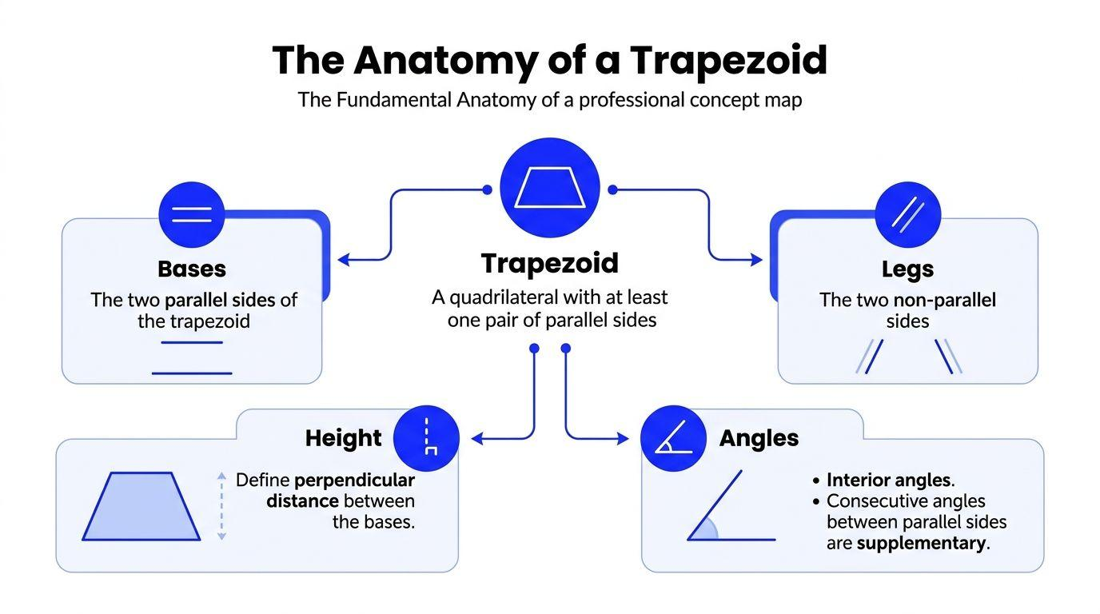
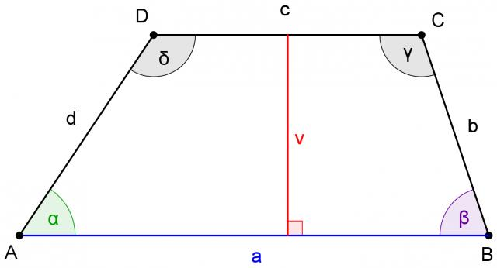
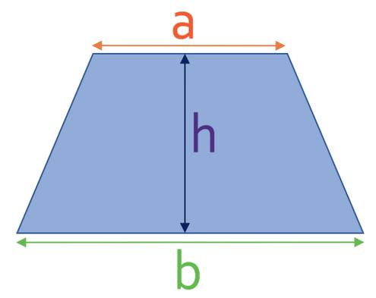
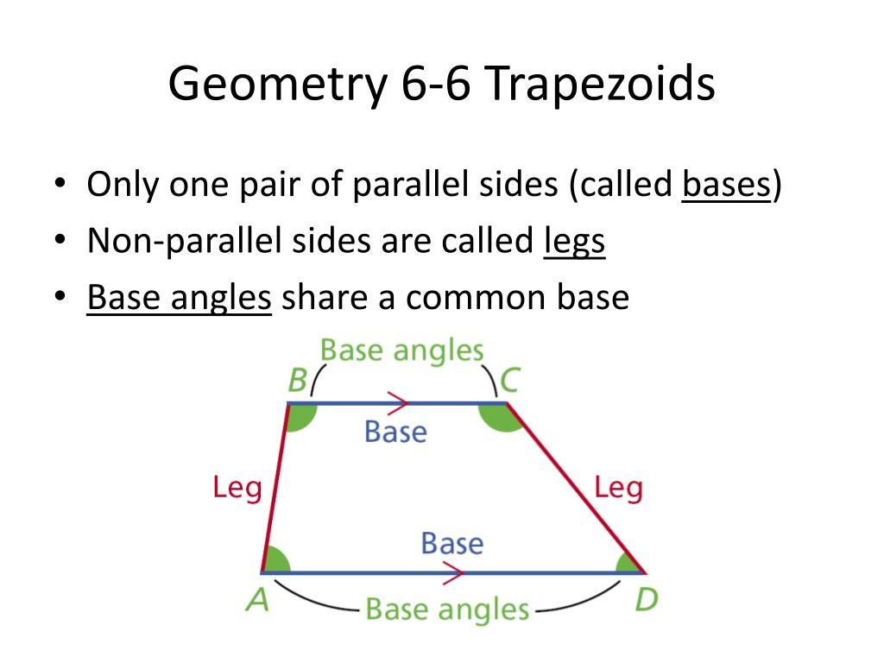
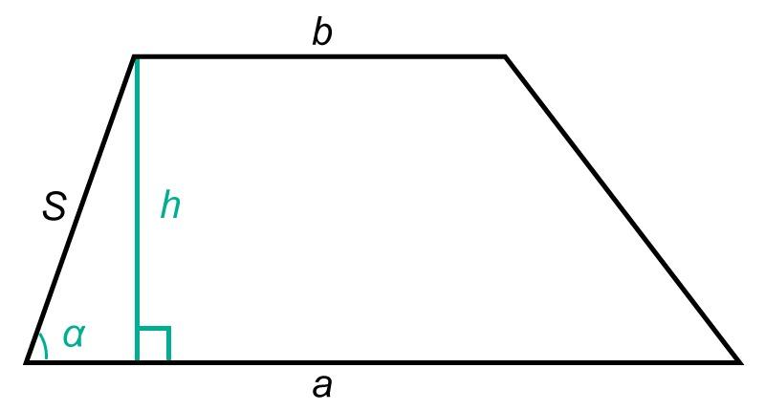
For trapezoid $ABCD$, if
$$AB∥CD$$
then $AB$and $CD$are the bases.

Purpose
# Source: AI Source: Provided by: [Data Path: Persons Table -> ID Column: 1, Name_En Column: Motasem Essam] -> From: [ChatGPT] on [7/25/2026]
A trapezoid is used to:
- Study quadrilaterals with one pair of parallel sides.
- Calculate area and perimeter.
- Analyze angles and parallel-line relationships.
- Model shapes found in architecture, engineering, and design.
- Serve as a foundation for understanding special trapezoids such as isosceles trapezoids and right trapezoids.

Fundamental Elements
# Source: AI Source: Provided by: [Data Path: Persons Table -> ID Column: 1, Name_En Column: Motasem Essam] -> From: [ChatGPT] on [7/25/2026]
Consider trapezoid $ABCD$with $AB∥CD$.
- Bases: $AB$and $CD$
- Legs: $AD$and $BC$
- Vertices: $A,B,C,D$
- Interior angles: $∠A,∠B,∠C,∠D$
- Height: perpendicular distance between the two bases
- Diagonals: $\overset{‾}{AC}$and $\overset{‾}{BD}$
The height is usually denoted by $h$.
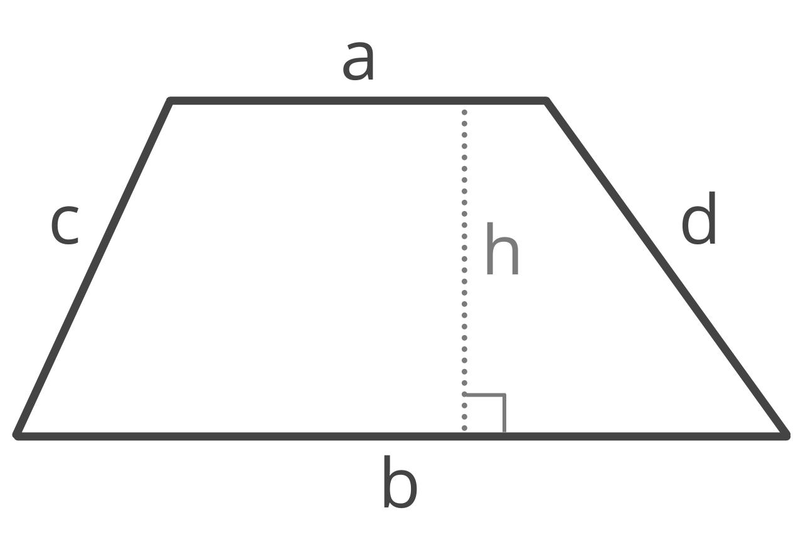
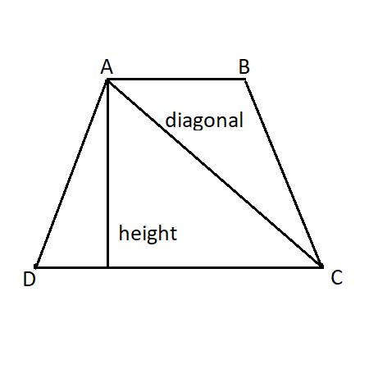
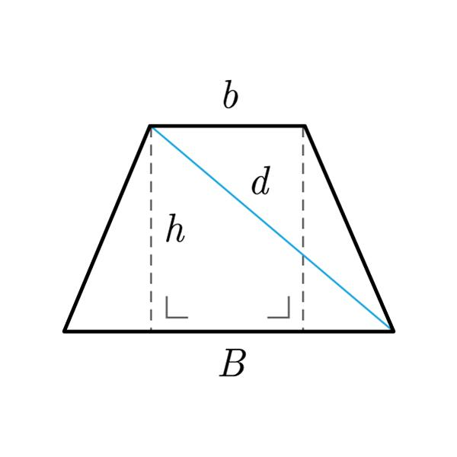
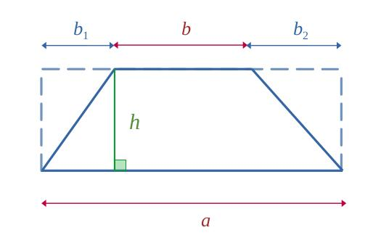
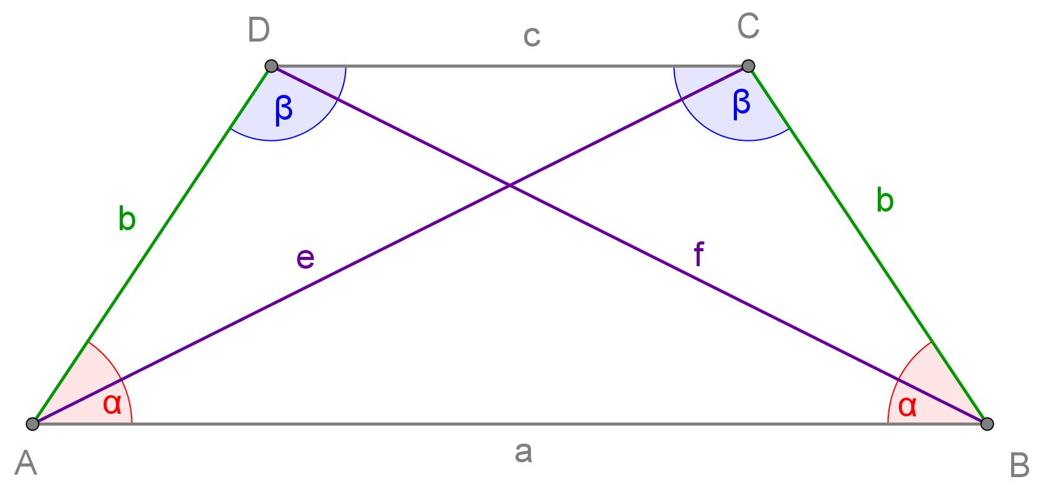

Mathematical Representation
# Source: AI Source: Provided by: [Data Path: Persons Table -> ID Column: 1, Name_En Column: Motasem Essam] -> From: [ChatGPT] on [7/25/2026]
Let:
- $a$= length of one base
- $b$= length of the other base
- $h$= height
- $c,d$= lengths of the legs
Area
The area of a trapezoid is
$$A=\frac{\left(a+b\right)h}{2}$$
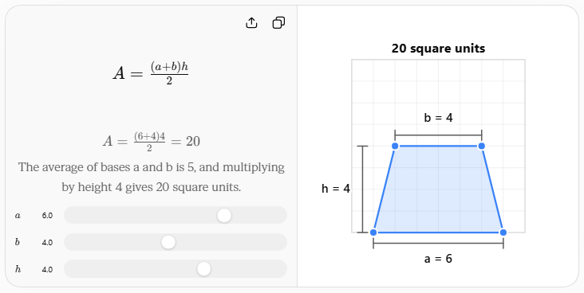This can also be written as
$$A=\left(\frac{a+b}{2}\right)h$$
Thus, the area equals the average of the two base lengths multiplied by the height.
Perimeter
$$P=a+b+c+d$$

Angle Properties
# Source: AI Source: Provided by: [Data Path: Persons Table -> ID Column: 1, Name_En Column: Motasem Essam] -> From: [ChatGPT] on [7/25/2026]
Because the bases are parallel, the consecutive interior angles along each leg are supplementary.
Therefore,
$$∠A+∠D={180}^{∘}$$
and
$$∠B+∠C={180}^{∘}$$
The sum of all interior angles of every trapezoid is
$$∠A+∠B+∠C+∠D={360}^{∘}$$

Midsegment of a Trapezoid
# Source: AI Source: Provided by: [Data Path: Persons Table -> ID Column: 1, Name_En Column: Motasem Essam] -> From: [ChatGPT] on [7/25/2026]
The midsegment is the segment connecting the midpoints of the two legs.
It is parallel to both bases.
If the bases have lengths $a$and $b$, the midsegment length $m$is
$$m=\frac{a+b}{2}$$
Therefore, the area can also be expressed as
$$A=mh$$
where $m$is the length of the midsegment.
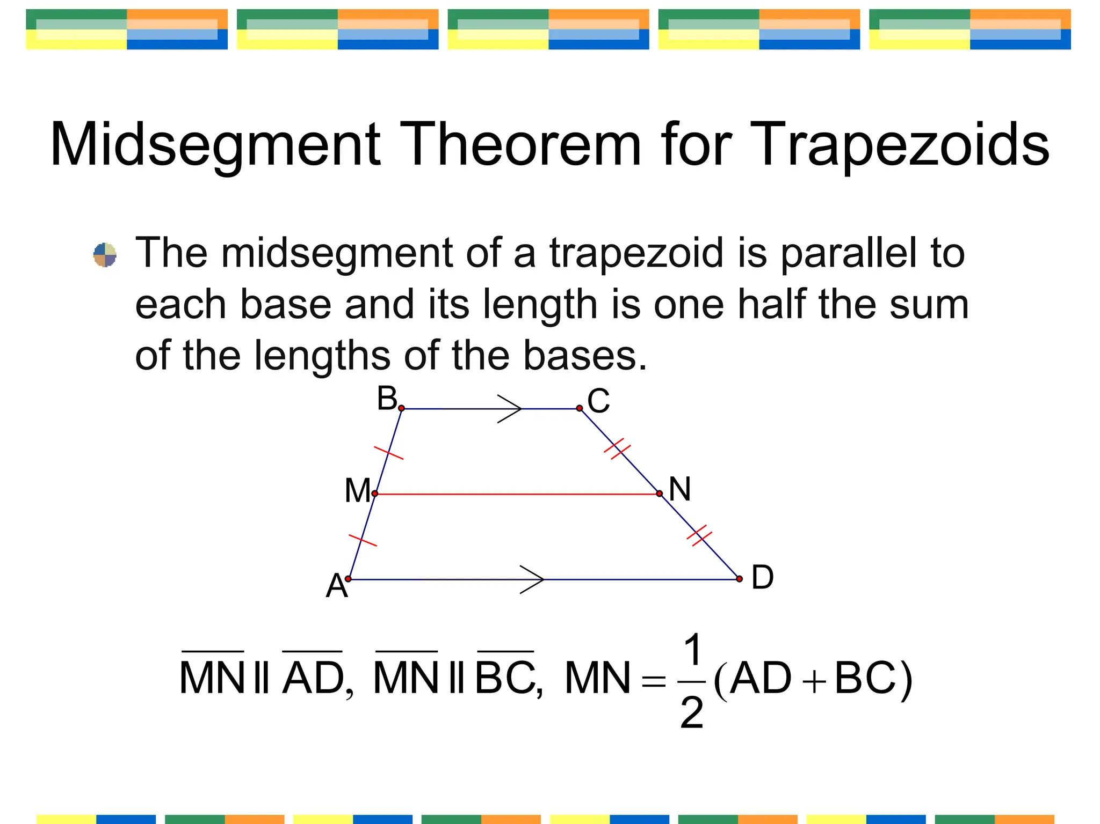
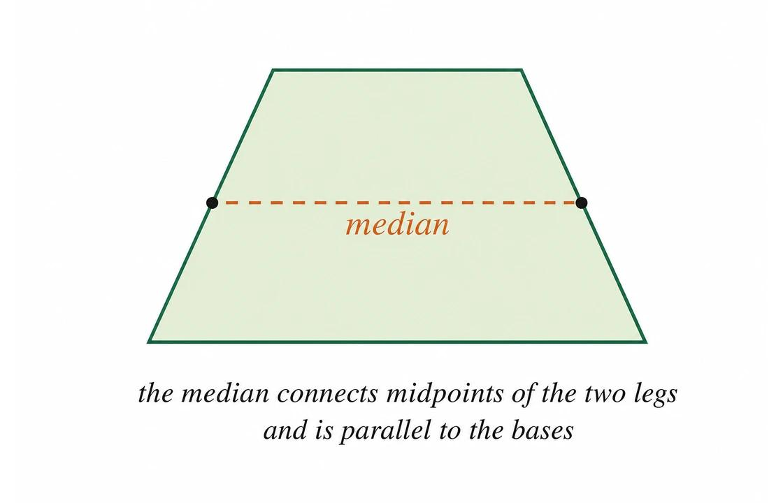
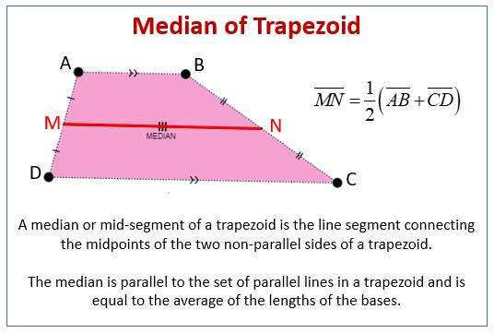
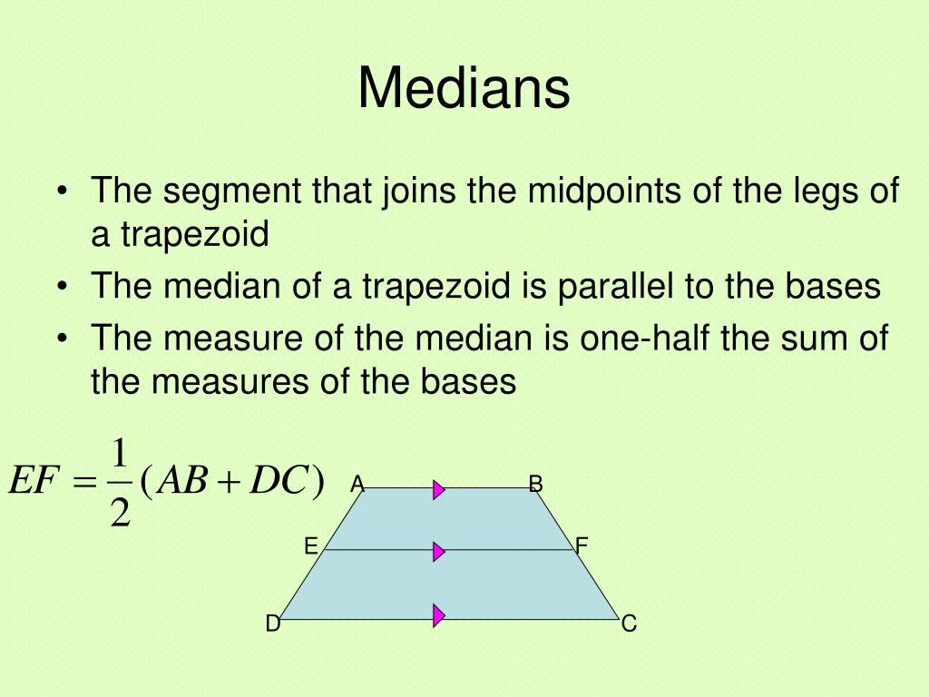
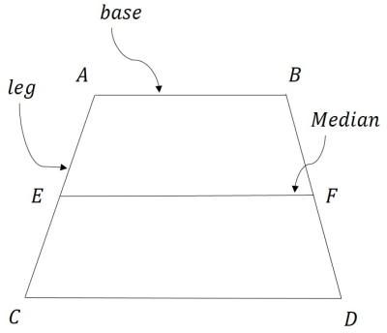

Types of Trapezoids

1. General Trapezoid
# Source: AI Source: Provided by: [Data Path: Persons Table -> ID Column: 1, Name_En Column: Motasem Essam] -> From: [ChatGPT] on [7/25/2026]
A general trapezoid has one pair of parallel bases, with no additional required special properties.

2. Isosceles Trapezoid
# Source: AI Source: Provided by: [Data Path: Persons Table -> ID Column: 1, Name_En Column: Motasem Essam] -> From: [ChatGPT] on [7/25/2026]
An isosceles trapezoid has congruent legs.
If
$$AD=BC$$
then $ABCD$is an isosceles trapezoid.
Its base angles are congruent:
$$∠A=∠B$$
and
$$∠D=∠C$$
Its diagonals are also congruent:
$$AC=BD$$
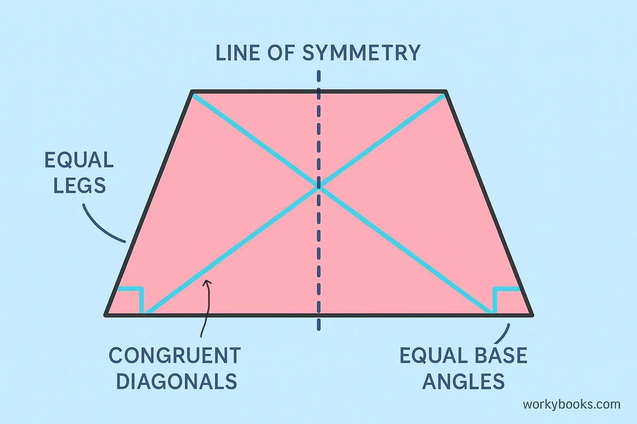
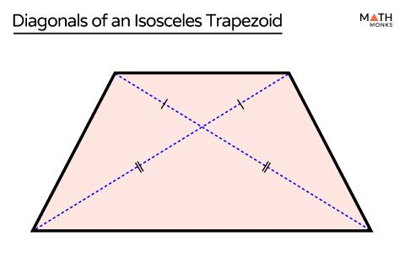
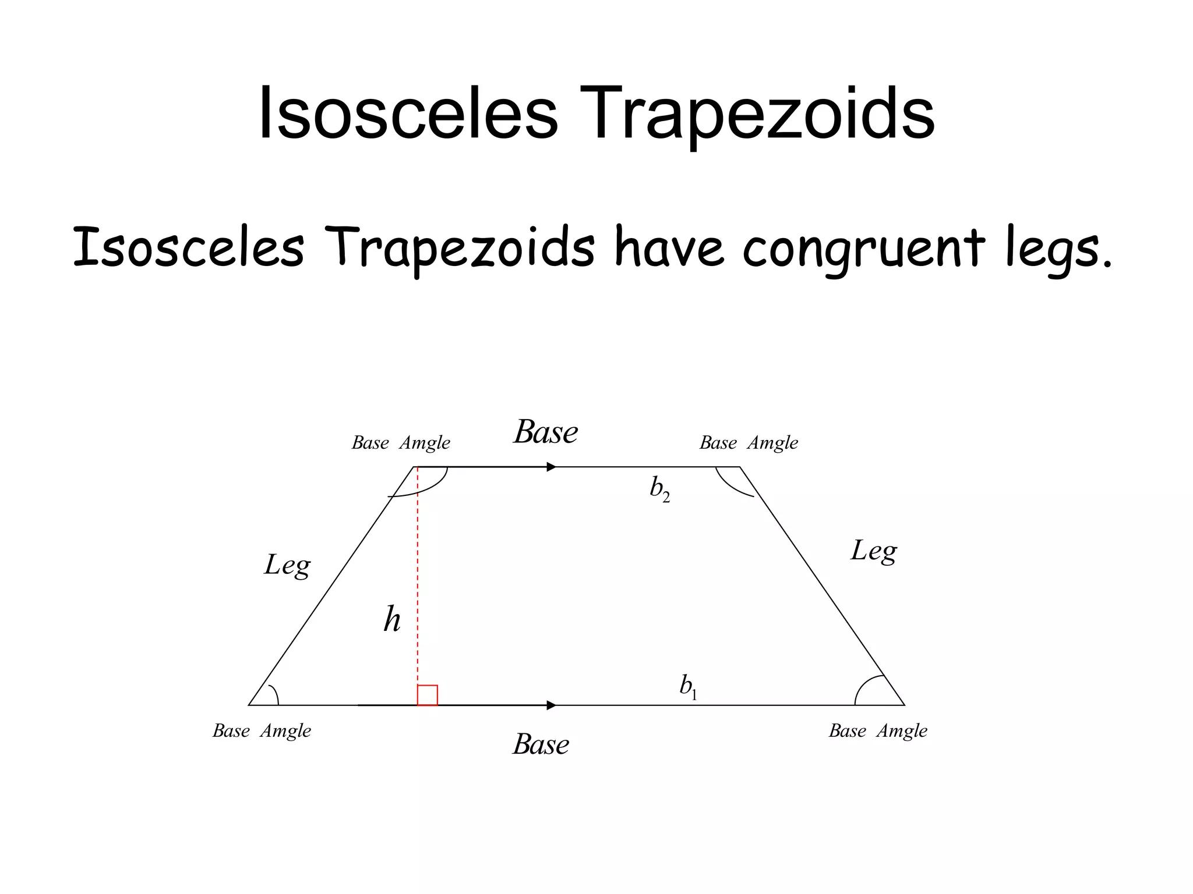
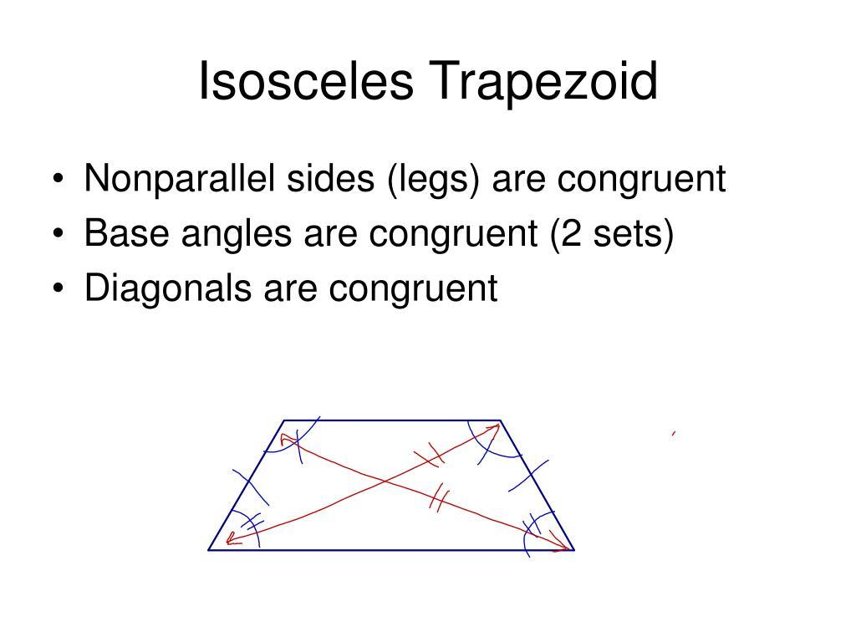
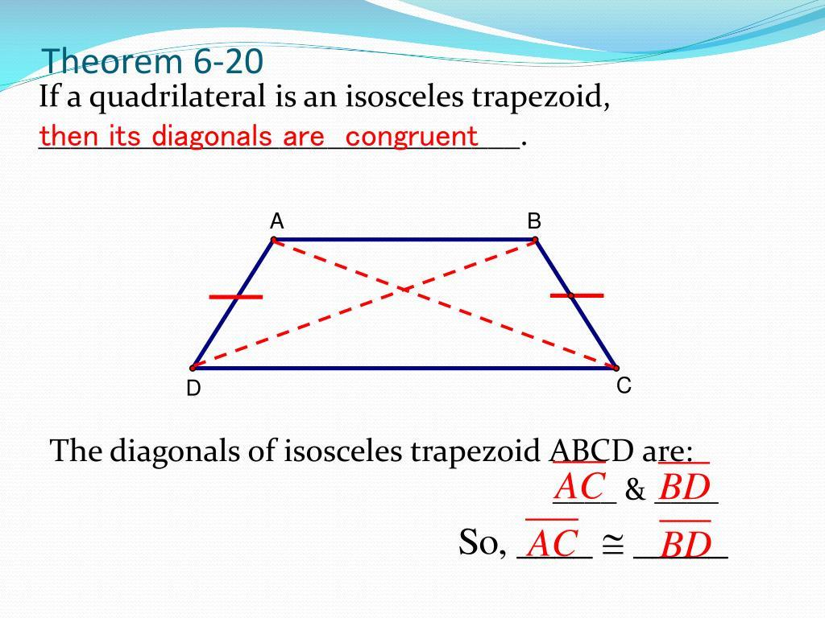

3. Right Trapezoid
# Source: AI Source: Provided by: [Data Path: Persons Table -> ID Column: 1, Name_En Column: Motasem Essam] -> From: [ChatGPT] on [7/25/2026]
A right trapezoid has two right angles.
For example,
$$∠A=∠D={90}^{∘}$$
One leg is therefore perpendicular to the bases and can serve as the height.
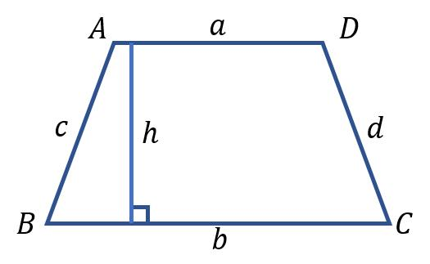
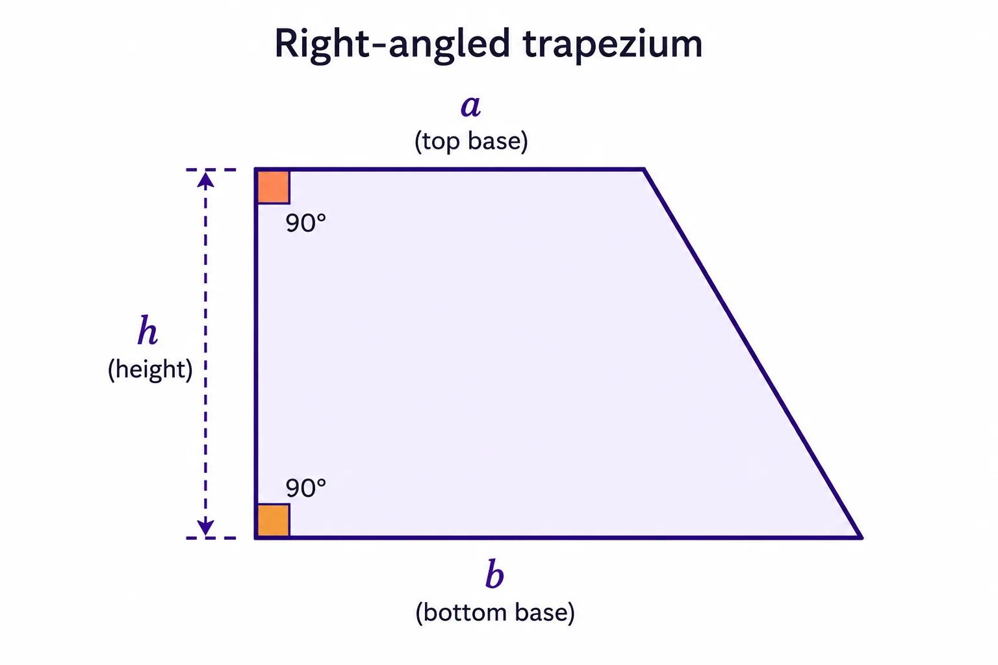
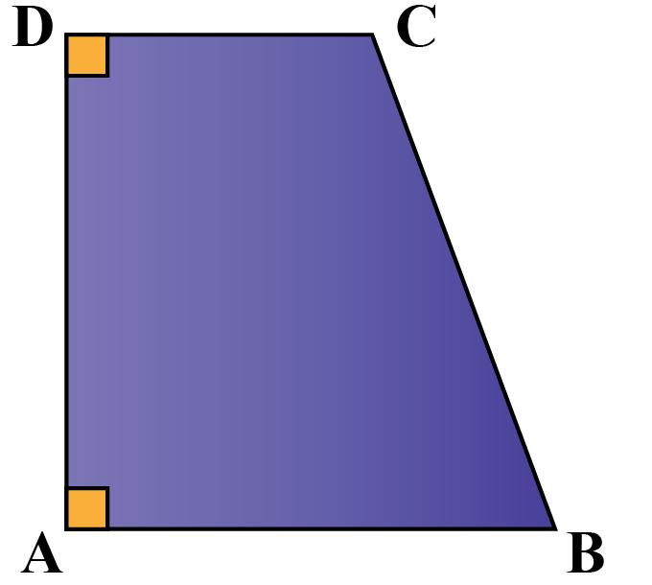
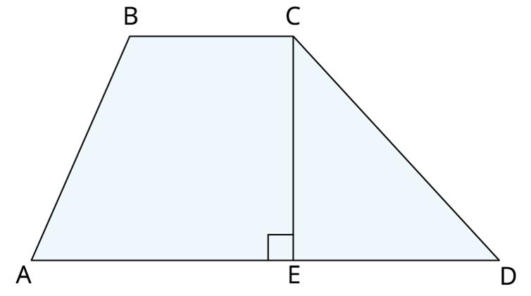
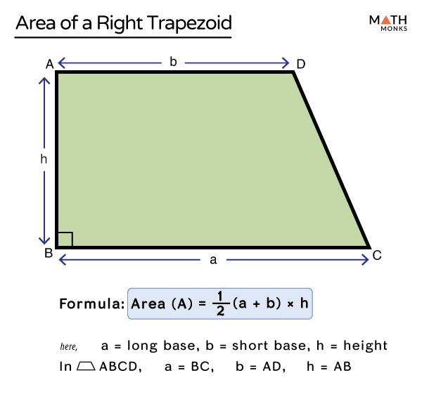

Important Properties
# Source: AI Source: Provided by: [Data Path: Persons Table -> ID Column: 1, Name_En Column: Motasem Essam] -> From: [ChatGPT] on [7/25/2026]
For a trapezoid with $AB∥CD$:
- It has four sides.
- It has four vertices.
- It has two bases.
- The bases are parallel.
- The other two sides are the legs.
- The height is perpendicular to the bases.
- The interior angles sum to ${360}^{∘}$.
- Consecutive angles along each leg are supplementary.
- Its area is
$$A=\frac{\left(a+b\right)h}{2}$$
- Its perimeter is
$$P=a+b+c+d$$
- Its midsegment is parallel to the bases.
- Its midsegment has length
$$m=\frac{a+b}{2}$$

Examples

Example 1: Finding the Area
# Source: AI Source: Provided by: [Data Path: Persons Table -> ID Column: 1, Name_En Column: Motasem Essam] -> From: [ChatGPT] on [7/25/2026]
Suppose a trapezoid has:
$$a=8\text{ cm} \\ b=14\text{ cm} \\ h=5\text{ cm}$$
Then
$$A=\frac{\left(a+b\right)h}{2} \\ A=\frac{\left(8+14\right)\left(5\right)}{2} \\ A=\frac{22×5}{2} \\ \boxed{A=55{\text{ cm}}^{2}}$$

Example 2: Finding the Perimeter
# Source: AI Source: Provided by: [Data Path: Persons Table -> ID Column: 1, Name_En Column: Motasem Essam] -> From: [ChatGPT] on [7/25/2026]
Suppose the four sides of a trapezoid are:
$$8\text{ cm}, 14\text{ cm}, 6\text{ cm}, 7\text{ cm}$$
Then
$$P=8+14+6+7 \\ \boxed{P=35\text{ cm}}$$

Example 3: Finding an Unknown Angle
# Source: AI Source: Provided by: [Data Path: Persons Table -> ID Column: 1, Name_En Column: Motasem Essam] -> From: [ChatGPT] on [7/25/2026]
Suppose
$$∠A={70}^{∘}$$
and $AB∥CD$.
Since $∠A$and $∠D$are supplementary,
$$∠A+∠D={180}^{∘}$$
Therefore,
$${70}^{∘}+∠D={180}^{∘} \\ \boxed{∠D={110}^{∘}}$$

Example 4: Finding the Midsegment
# Source: AI Source: Provided by: [Data Path: Persons Table -> ID Column: 1, Name_En Column: Motasem Essam] -> From: [ChatGPT] on [7/25/2026]
Suppose the bases are
$$a=10\text{ cm}$$
and
$$b=18\text{ cm}$$
Then
$$m=\frac{a+b}{2} \\ m=\frac{10+18}{2} \\ \boxed{m=14\text{ cm}}$$

Trapezoid vs. Special Trapezoids
# Source: AI Source: Provided by: [Data Path: Persons Table -> ID Column: 1, Name_En Column: Motasem Essam] -> From: [ChatGPT] on [7/25/2026]
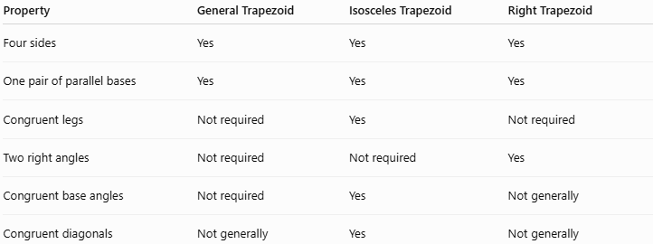
Property | General Trapezoid | Isosceles Trapezoid | Right Trapezoid
Four sides | Yes | Yes | Yes
One pair of parallel bases | Yes | Yes | Yes
Congruent legs | Not required | Yes | Not required
Two right angles | Not required | Not required | Yes
Congruent base angles | Not required | Yes | Not generally
Congruent diagonals | Not generally | Yes | Not generally

Relationship with Other Quadrilaterals
# Source: AI Source: Provided by: [Data Path: Persons Table -> ID Column: 1, Name_En Column: Motasem Essam] -> From: [ChatGPT] on [7/25/2026]
A trapezoid is a type of quadrilateral.
Under the common exclusive definition used in some curricula, a trapezoid has exactly one pair of parallel sides. Under the inclusive definition, it has at least one pair, so a parallelogram can also be considered a trapezoid.
For a knowledge base, it is useful to specify which convention you use.
A useful hierarchy is:
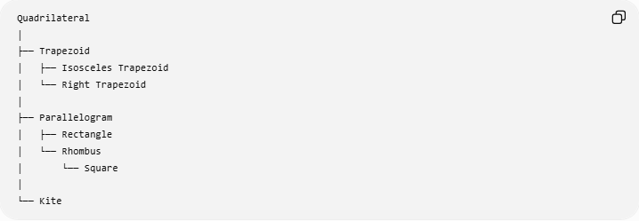
Quadrilateral
│
├── Trapezoid
│ ├── Isosceles Trapezoid
│ └── Right Trapezoid
│
├── Parallelogram
│ ├── Rectangle
│ └── Rhombus
│ └── Square
│
└── Kite

Real-World Applications
# Source: AI Source: Provided by: [Data Path: Persons Table -> ID Column: 1, Name_En Column: Motasem Essam] -> From: [ChatGPT] on [7/25/2026]
Trapezoidal shapes appear in:
- Bridges and bridge supports
- Roof structures
- Architectural designs
- Road signs
- Tables and furniture
- Engineering components
- Mechanical structures
- Containers and packaging
- Land plots
- Stadium and building layouts
- Decorative patterns
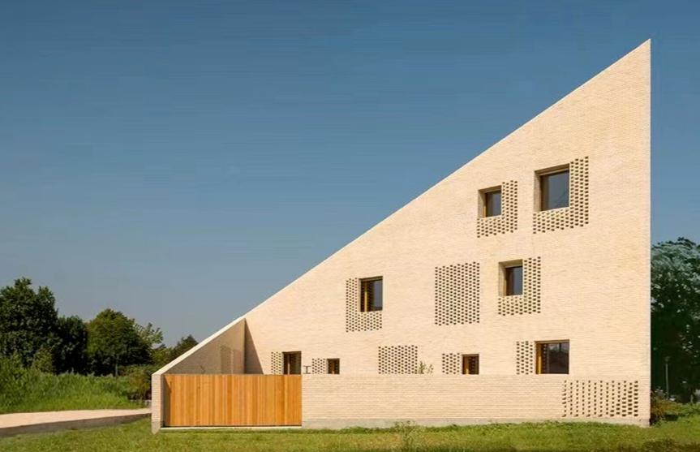
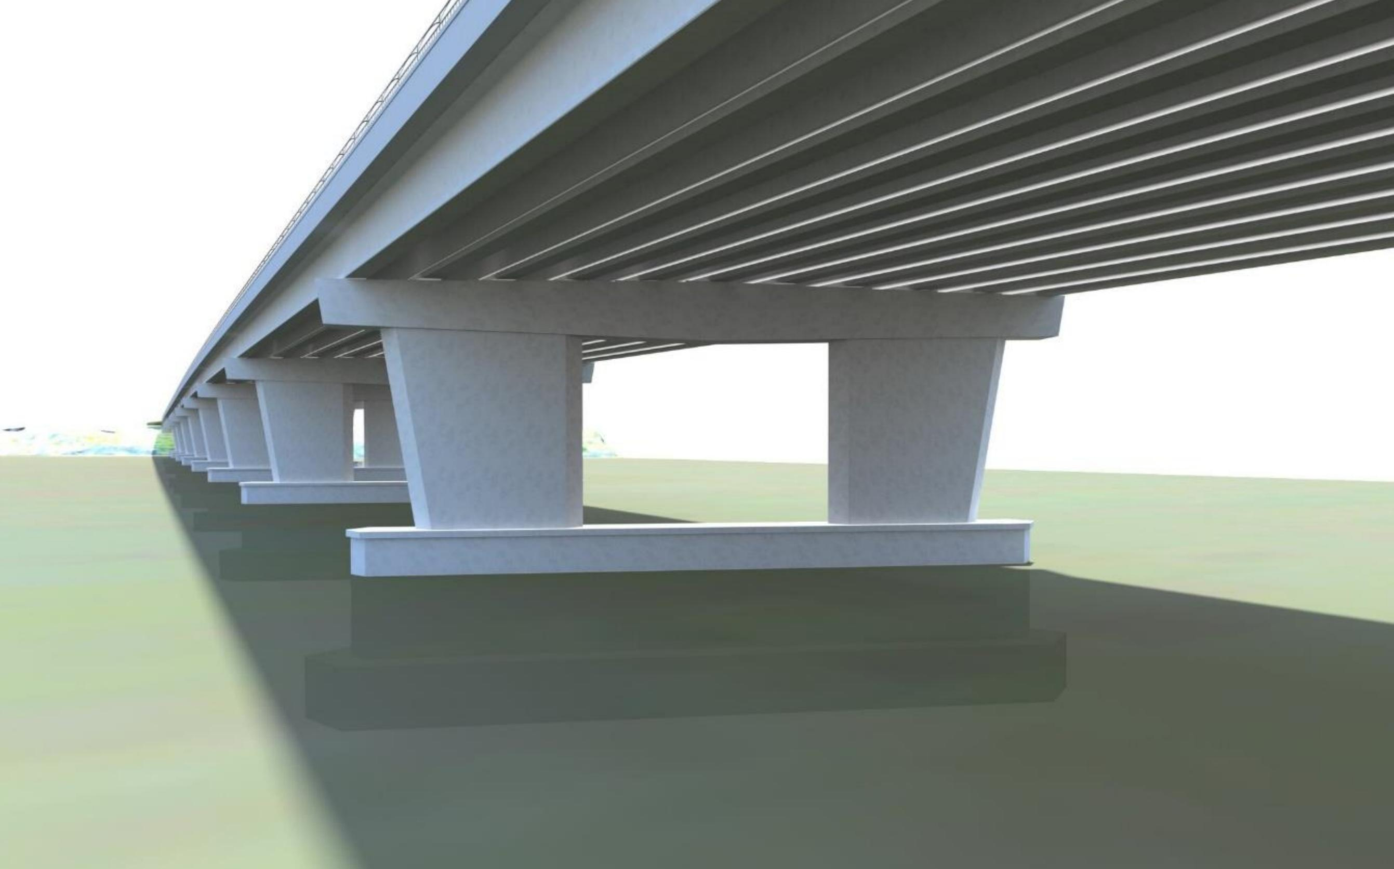
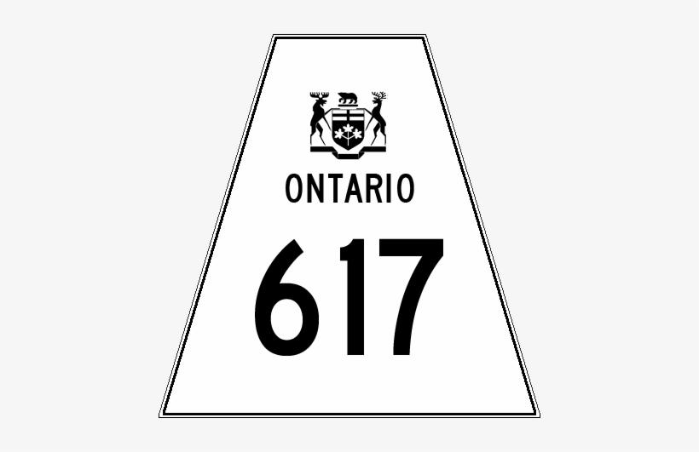
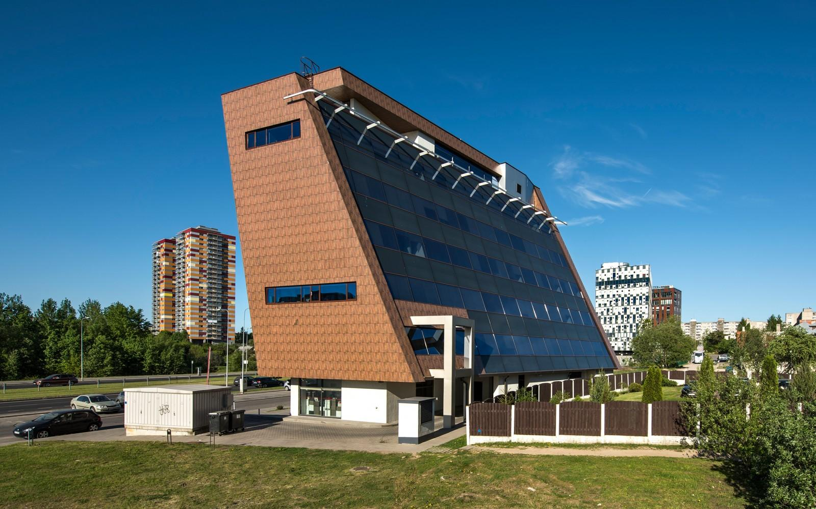
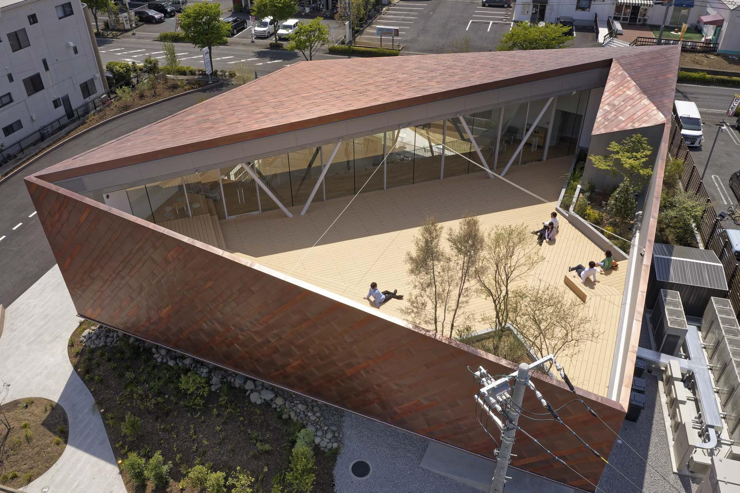

Advantages
# Source: AI Source: Provided by: [Data Path: Persons Table -> ID Column: 1, Name_En Column: Motasem Essam] -> From: [ChatGPT] on [7/25/2026]
- Simple area formula.
- Useful for modeling many real-world shapes.
- Includes several important special cases.
- Provides a bridge between general quadrilaterals and parallelograms.
- Its parallel bases make angle and area relationships easier to analyze.

Limitations
# Source: AI Source: Provided by: [Data Path: Persons Table -> ID Column: 1, Name_En Column: Motasem Essam] -> From: [ChatGPT] on [7/25/2026]
- The legs do not generally have equal lengths.
- The diagonals are not generally equal.
- The diagonals are not generally perpendicular.
- It does not generally have lines of symmetry.
- Its properties depend on whether it is a general, isosceles, or right trapezoid.

Comparison with Related Quadrilaterals
# Source: AI Source: Provided by: [Data Path: Persons Table -> ID Column: 1, Name_En Column: Motasem Essam] -> From: [ChatGPT] on [7/25/2026]
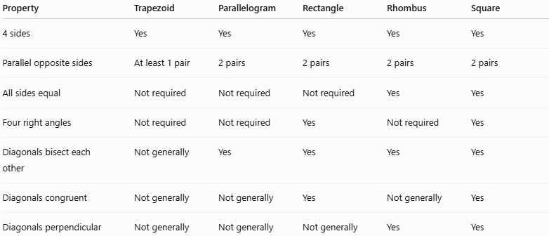
Property | Trapezoid | Parallelogram | Rectangle | Rhombus | Square
4 sides | Yes | Yes | Yes | Yes | Yes
Parallel opposite sides | At least 1 pair | 2 pairs | 2 pairs | 2 pairs | 2 pairs
All sides equal | Not required | Not required | Not required | Yes | Yes
Four right angles | Not required | Not required | Yes | Not required | Yes
Diagonals bisect each other | Not generally | Yes | Yes | Yes | Yes
Diagonals congruent | Not generally | Not generally | Yes | Not generally | Yes
Diagonals perpendicular | Not generally | Not generally | Not generally | Yes | Yes

Key Points
# Source: AI Source: Provided by: [Data Path: Persons Table -> ID Column: 1, Name_En Column: Motasem Essam] -> From: [ChatGPT] on [7/25/2026]
- A trapezoid is a quadrilateral with at least one pair of parallel sides under the inclusive definition.
- The parallel sides are called bases.
- The non-parallel sides are called legs.
- The height is the perpendicular distance between the bases.
- Area:
$$\boxed{A=\frac{\left(a+b\right)h}{2}}$$
- Perimeter:
$$\boxed{P=a+b+c+d}$$
- Midsegment:
$$\boxed{m=\frac{a+b}{2}}$$
- The interior angles always sum to:
$$\boxed{{360}^{∘}}$$
- An isosceles trapezoid has congruent legs and congruent pairs of base angles.
- A right trapezoid has two right angles.

Conclusion
# Source: AI Source: Provided by: [Data Path: Persons Table -> ID Column: 1, Name_En Column: Motasem Essam] -> From: [ChatGPT] on [7/25/2026]
A trapezoid is an important type of quadrilateral characterized by its parallel bases. Its most important mathematical relationships involve its bases, height, area, perimeter, angles, and midsegment. Special forms such as the isosceles trapezoid and right trapezoid add further geometric properties, making trapezoids important in both theoretical geometry and real-world applications.
Would you like a short trapezoid study sheet or a few practice problems?

